**Final Documentation of the project File**

**Course Name: ITMD 411 (Intermediate programming)**

**Name: Muhammad Hamza Mobeen**

“I have built an app a GUI which is IIT help desk Login which helps to understand the users and their incoming requests You can either add a user or delete a user or update a user add and delete the ticket. Below are the Screenshots of the application:

**Firstly, Extra Credit Git hub repo:**

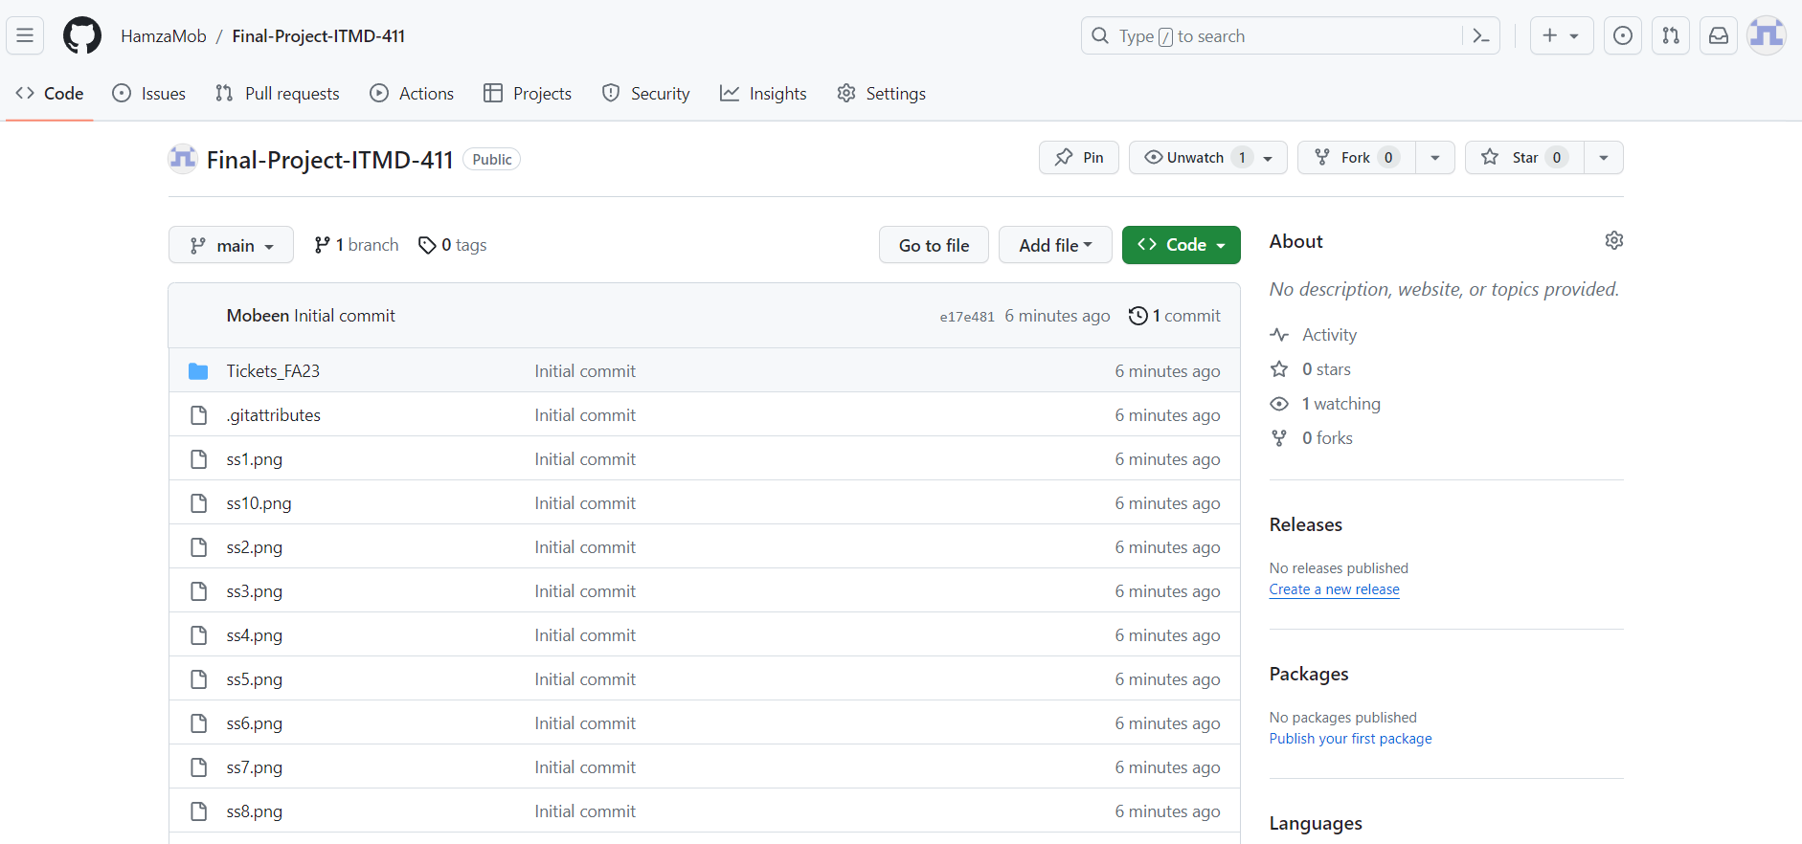

**Extra Credit Fluent app features and App Screen shots which also Includes Update, delete and inserting Tickets:**

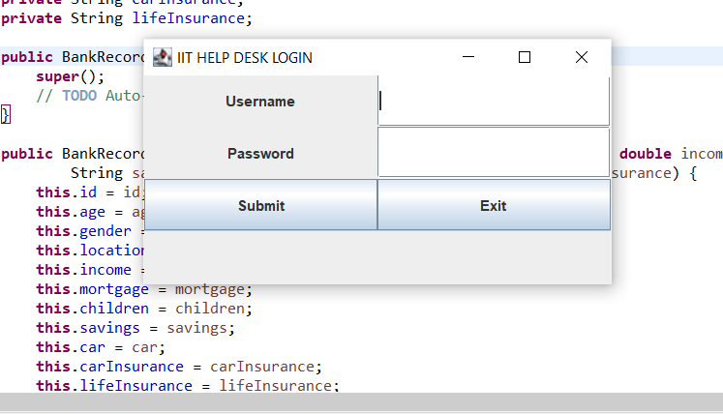

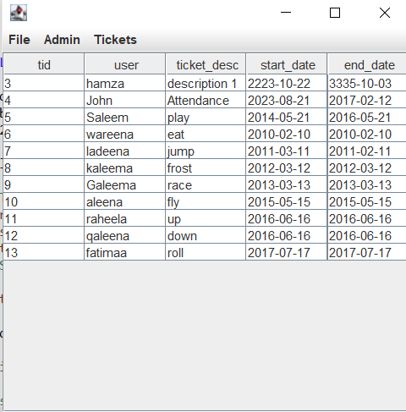

**Fluent Interface:**

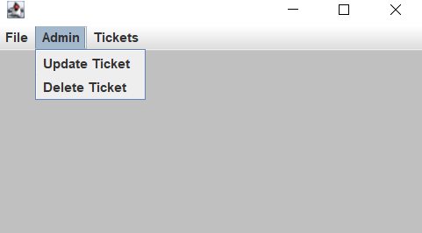

**Inserting 10 Users:**



**Updating:**

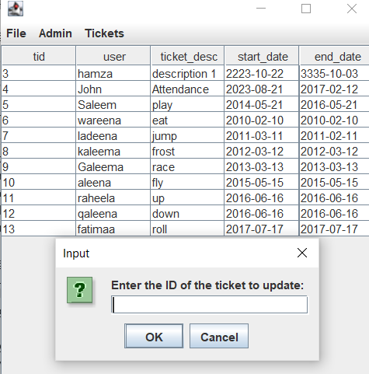

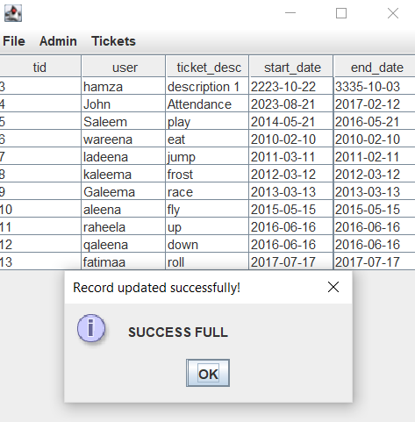

**Deleting a Ticket:**

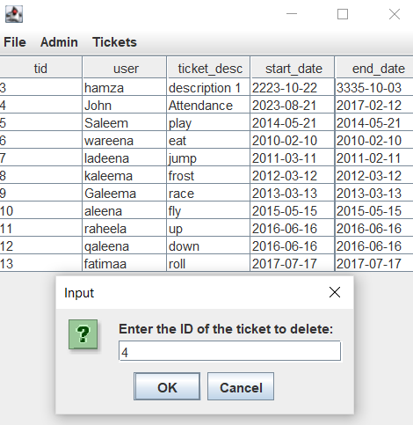

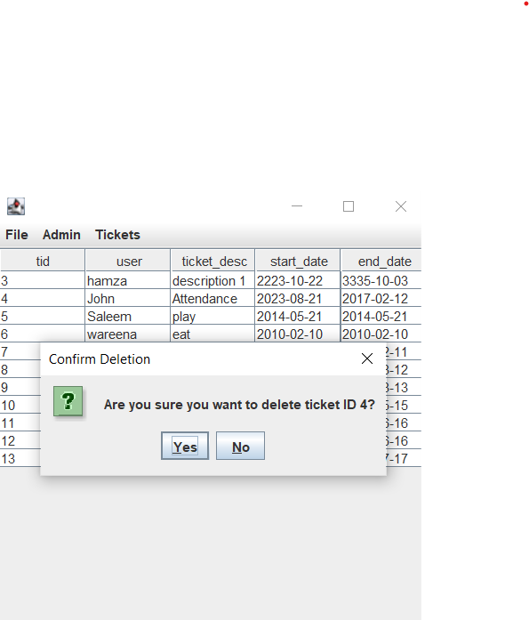

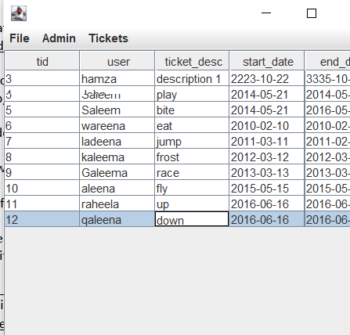

**Database Picture:**

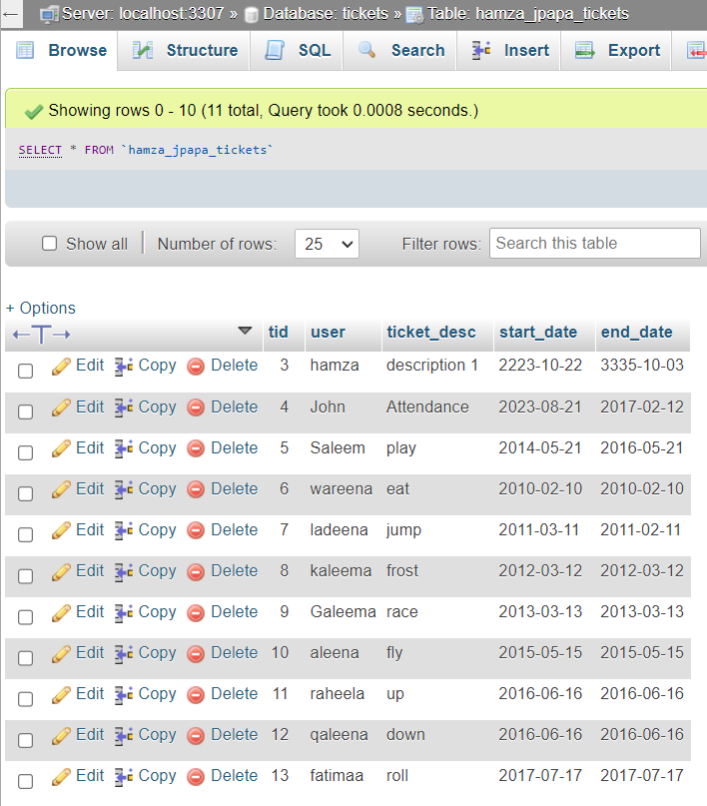

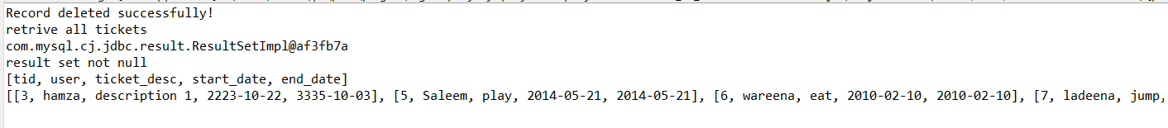

**See the status of the Ticket:**

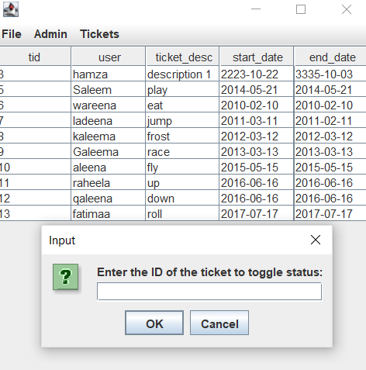

**Extra Credit Added and updated GUI interface for better Toggling:**

